University admission
1.Problem:
Evalute candidates using subject eligibility ,aggregate , marks , course-specific thresholds and tie breaking criteria. Generate a ranked lists of eligible applications.
2.Objectives:
To check subject_wise minimum 50 marks. To check total>=cutoff (180).To ramk eligible students by total,tie by maths marks.
3.Assumptions:
Each subject min 50 required. Cse cutoff 180 total. Tie-breaking :higher maths marks gets higher rank.
4.Algorithm:
Start
Input n students with maths , physics , chemistry
For ech student
Total=m+p+c
If m>=50 and p>=50 and c>=50 and total then add to eligible sort descending by total ,then maths
Print(ranked list)
End
5.Pseudo code:
Read n
Eligible =[ ]
For i=1 to n:
Read m,p,c name
If m>=50 and p>=50 and c>=50 and (m+p+c) > =180
Eligible .append()
Print(eligible)
6.Test cases:
1.A=80,70,60=210 | eligible | Rank(1)
2.B=40,70,70=180 | Not eligible | pass

7.Flow chart:
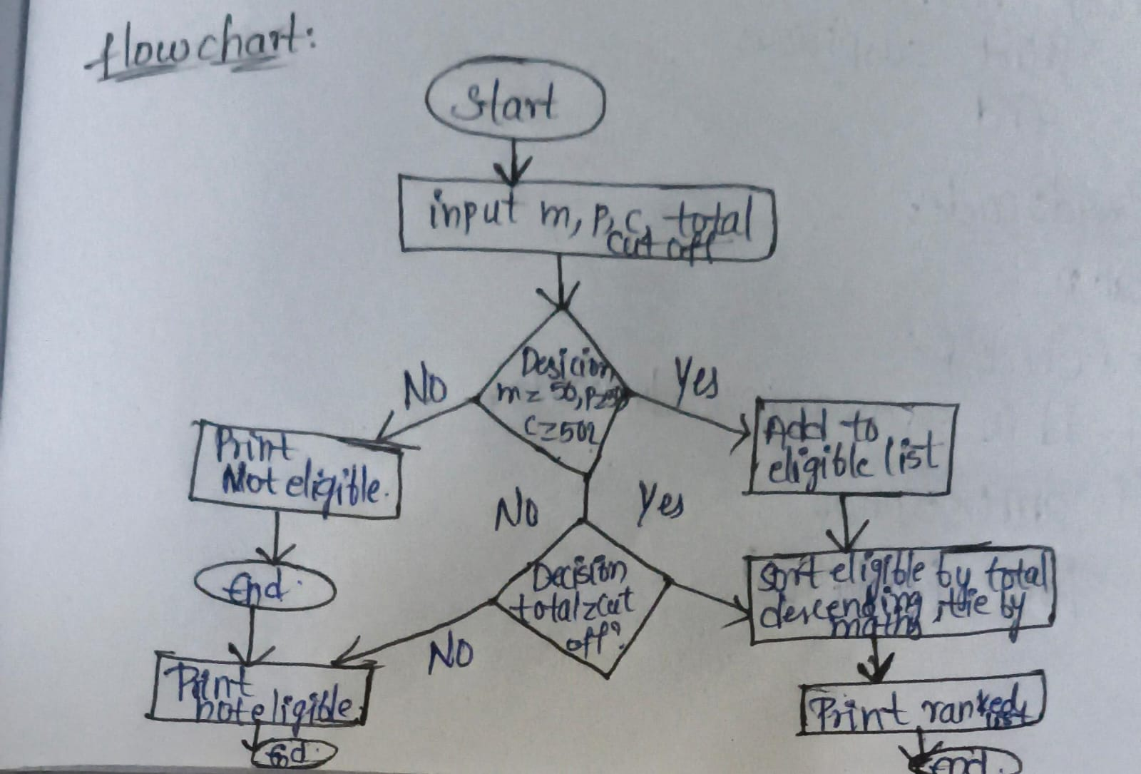

8.code:
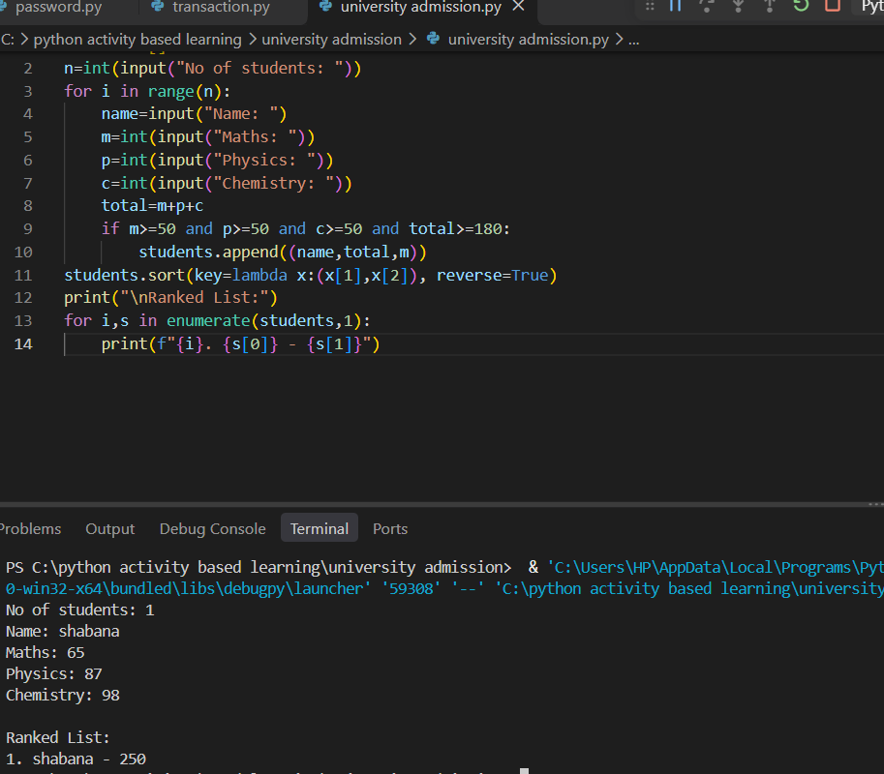
9.Conclusion:
All test cases are passed and by using the loops.

